GRADE 7 ACCELERATED · UNIT 2 · LESSON 2  Square Values and Square Roots  Additional Practice 7A.02.02 | Name_________________________  Date__________________________  Period________________________

1. Label the three parts of the radical expression.
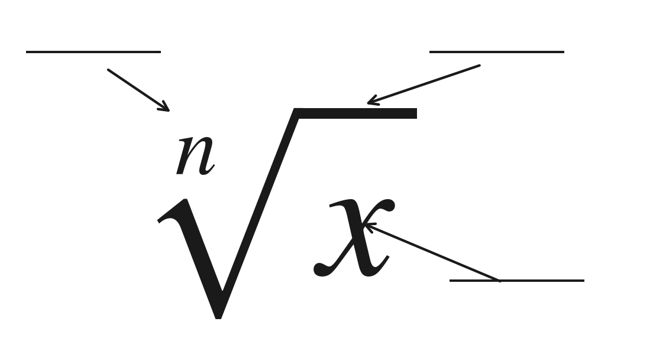
2. Fill in both boxes. They do not get the same answer.
The radical on its own | The equation
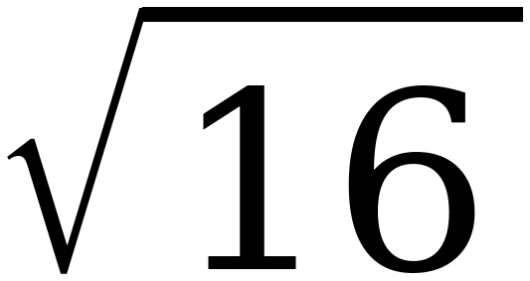 | x² = 16

For questions 3 through 6, find the value.
3. 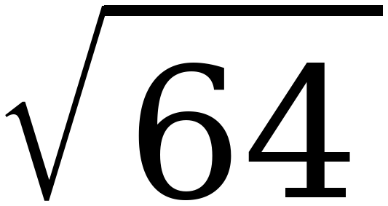

4. 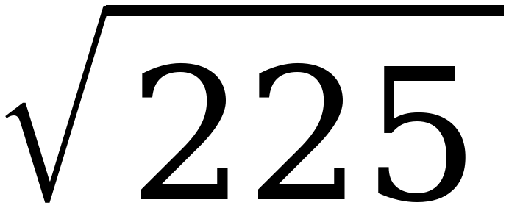

5. 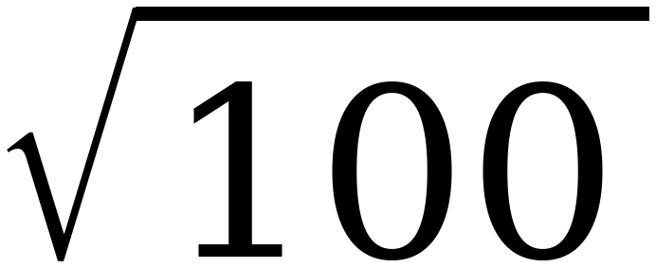

6. 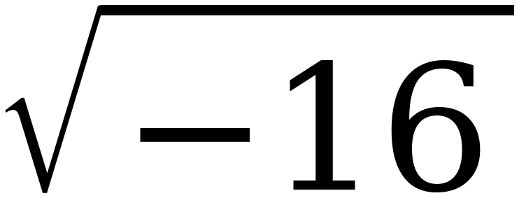

For questions 7 through 10, find every real solution of the equation.
7. x² = 25

8. 196 = a²

9. n² = 0

10. x² = −100

11. Select ALL of the values below that make x² = 144 true.
☐ | 12 | ☐ | 72
☐ | −12 | ☐ | 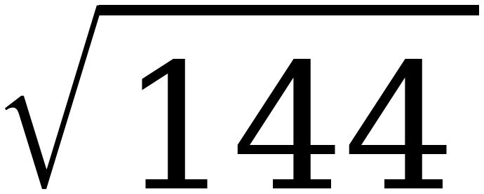
☐ | − | ☐ | 288

12. Owen writes the statement below on his paper.
= ±10
Explain what is wrong with Owen's statement, then write the two correct statements it should have been.

